T40 Restore Factory Settings

Note: After the following steps are completed, all the data in the partition where the system is located (usually the C drive) will be deleted, so please make sure there is no important data before you operate;

1) T40 power on, after the Windows interface appears (Windows desktop or Windows OOBE wizard interface), long press the power on button until the power on indicator light goes out; then again this short press the power on button to power on the T40, and so on after entering the Windows interface (Windows desktop or Windows OOBE wizard interface), long press the power on button until the The power on indicator light is off; finally press the power on button again to power on the T40, then it will enter the recovery environment as shown in step 2; power on the T40, after the Windows interface appears (Windows desktop or Windows OOBE wizard interface), long press the power on button until the power on indicator light is off; then press the power on button again to power on the T40, then enter the Windows interface (Windows desktop or Windows OOBE wizard interface), long press the power on button until the power on indicator light is off. （After entering the Windows interface (Windows desktop or Windows OOBE wizard interface), press and hold the power on button until the power on indicator light goes off; finally press the power on button again to power on the computer, and then it will enter the recovery environment shown in step 2);
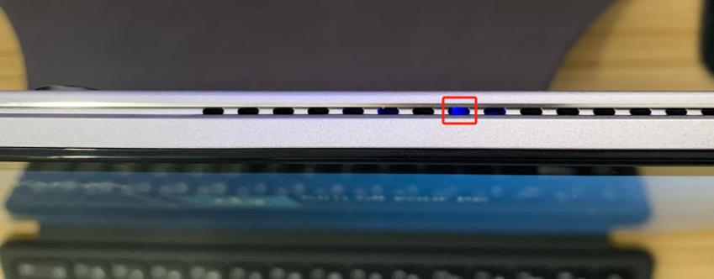T40 power-on indicator

2) After entering the recovery mode, just follow the step-by-step operation as shown below;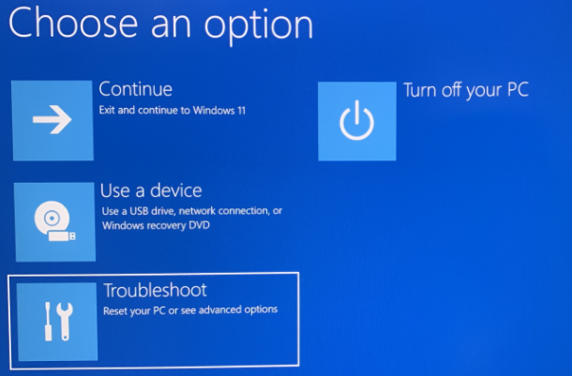
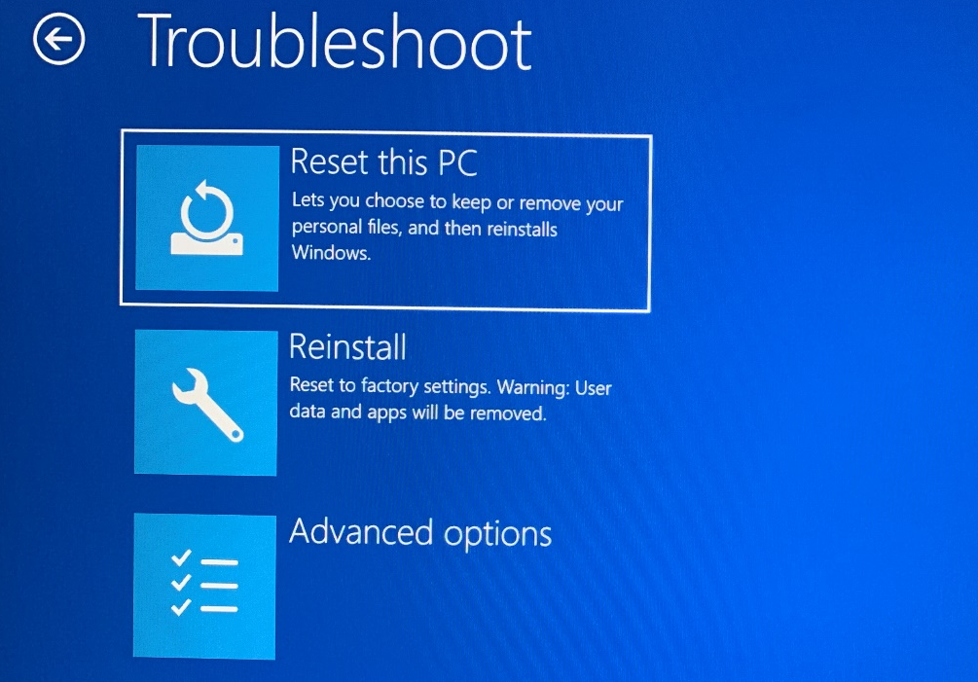
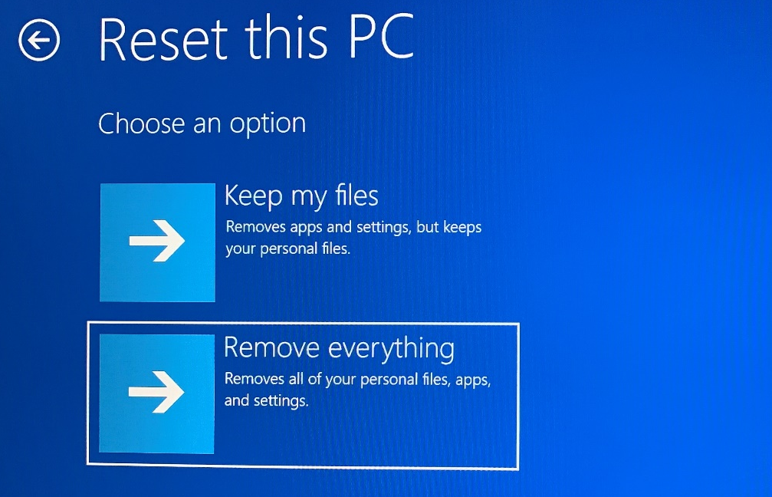
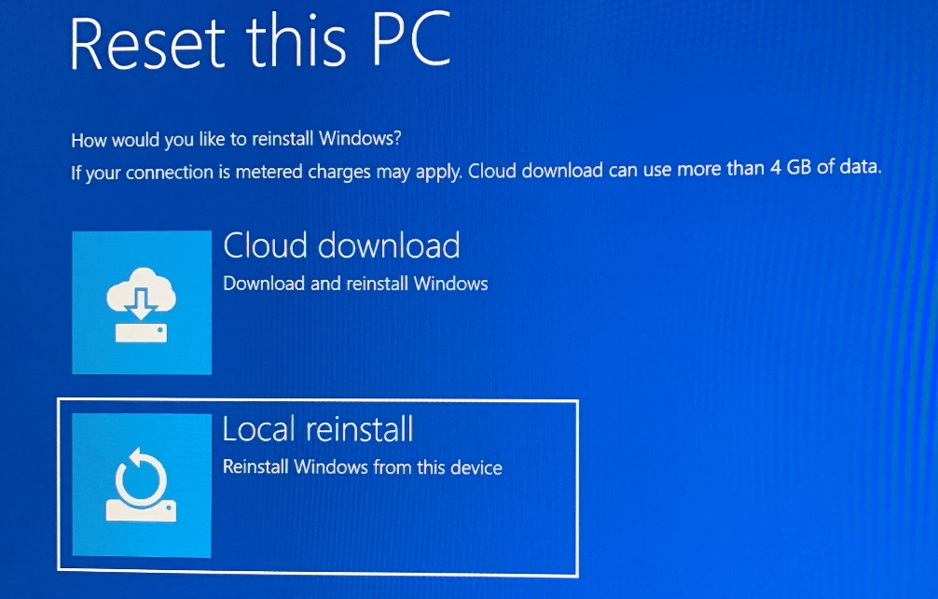
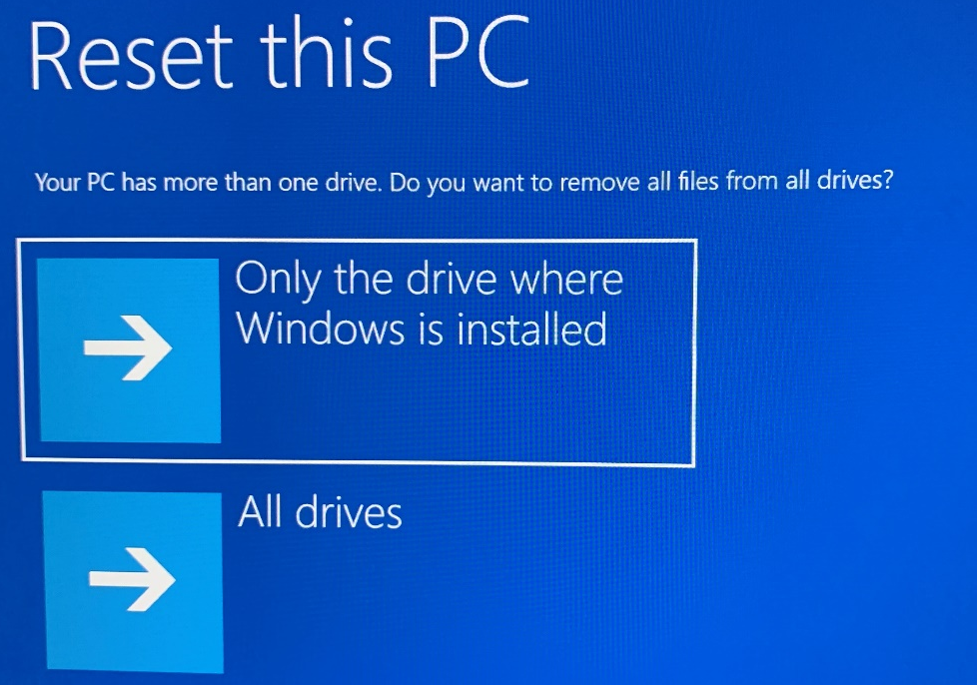
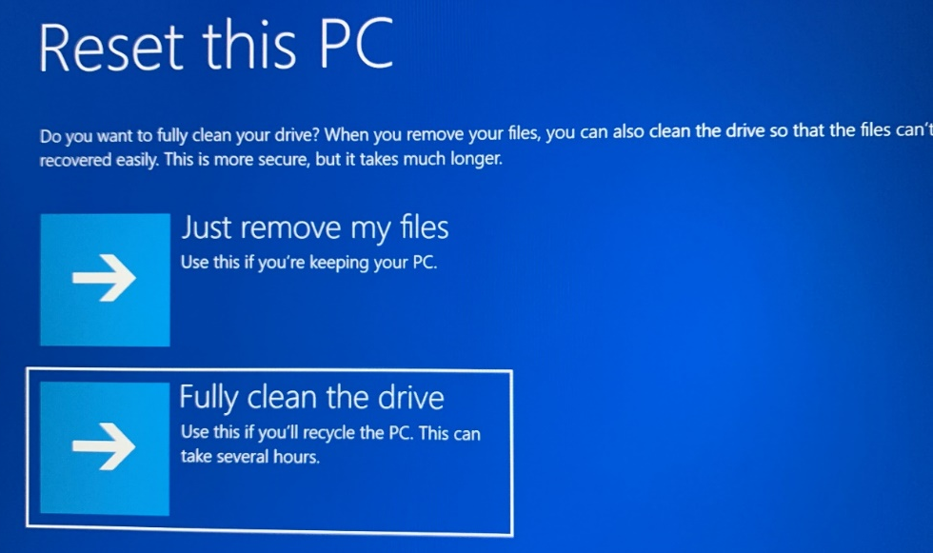
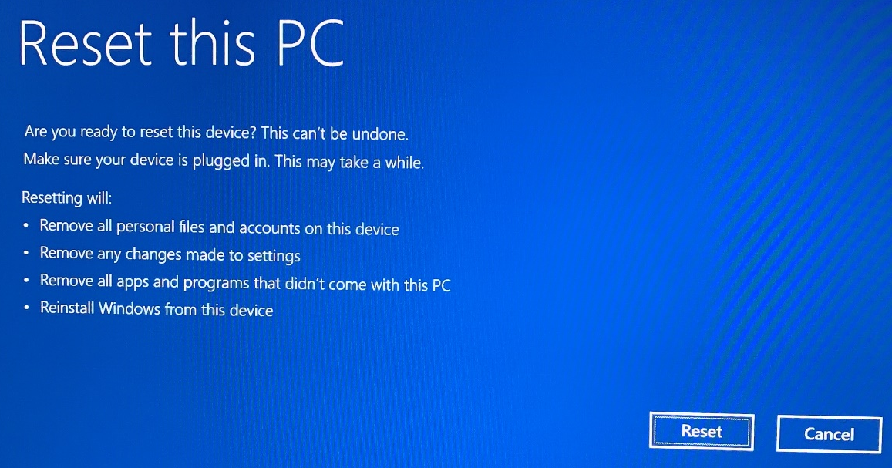
Click on the [Reset] button to begin the reset process
This process will take a long time (may take 2-3 hours), please be patient!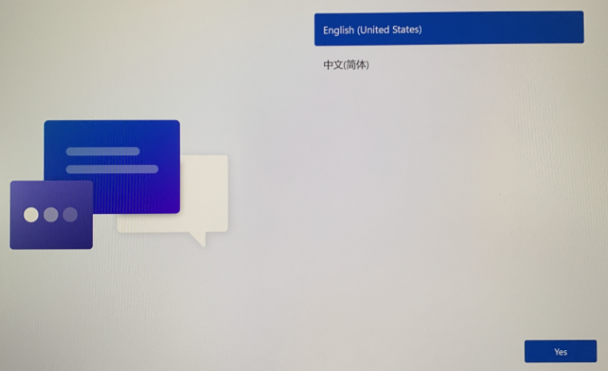
Finally, go to the OOBE screen and follow the wizard to recreate the account;

