N16Pro Disassembly and assembly of fingerprint cable
Please remove the bottom cover and internal battery screws first, and then remove the battery;
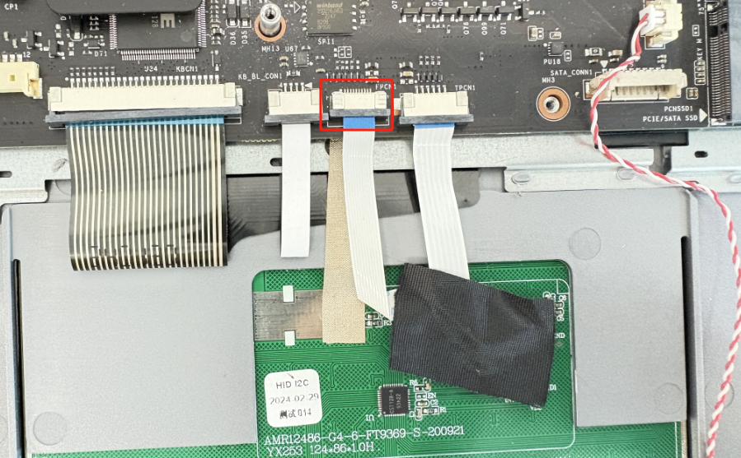
The fingerprint plug is shown in the above figure
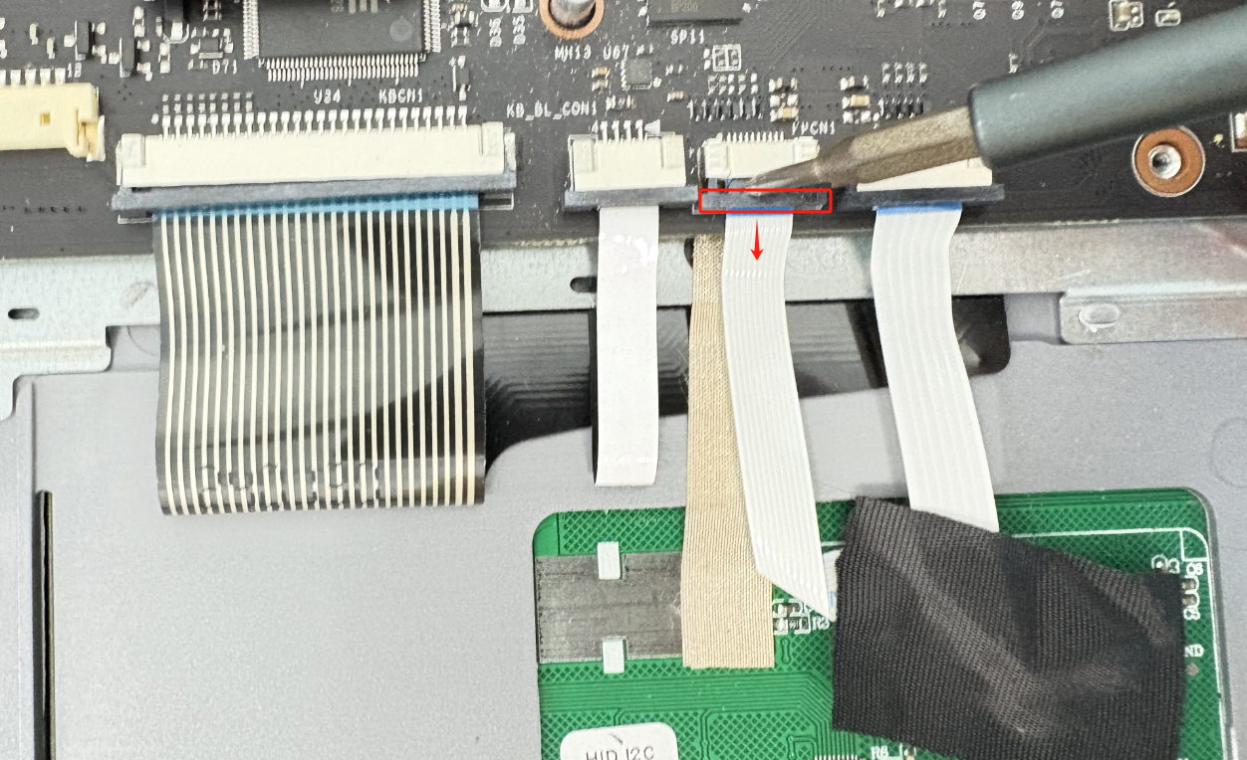
Pull the black buckle outward
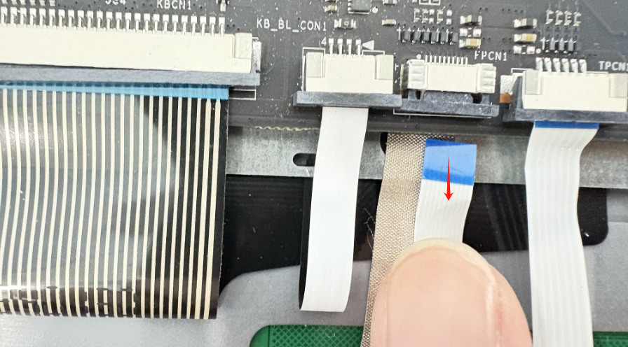
Gently pull out the fingerprint cable
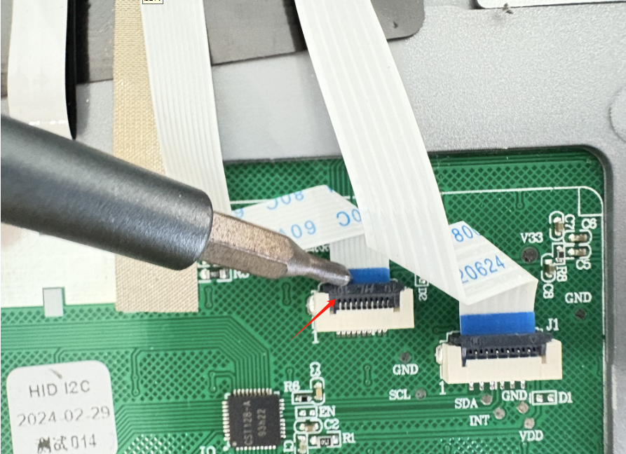
The other end of the fingerprint cable needs to be removed using a different method, which requires pulling the black buckle upwards
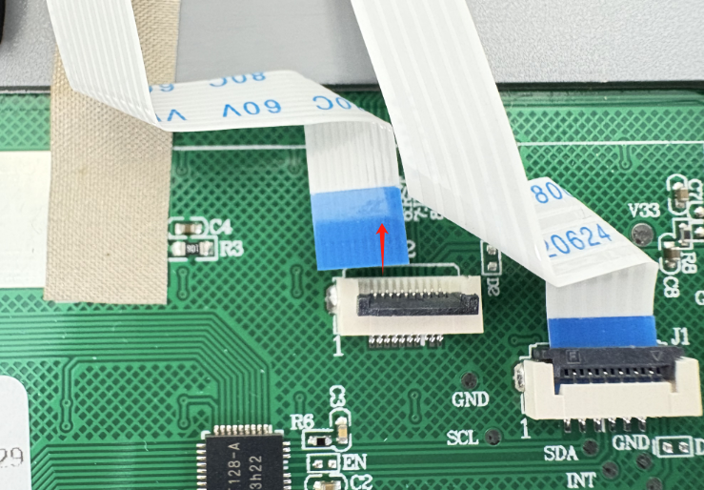
Then pull out the fingerprint cable
Finally, please reinstall the fingerprint cable and push in or press down the buckle; Reinstall the battery screws and battery cables, and install the bottom cover;

